English First Additional Language: Grade 10
Lockdown work – Week 2
Hi guys!
I hope you are all still doing well and enjoying this time with your families.
This is the new work you have to complete this week. Please do your best in these activities as they will make it much easier for us to complete everything for the year. Also, remember that you have to plan and prepare your speeches and prepared reading!
Next week we will be doing literature, so dust those books off!
Please also join our Whatsapp group if you haven’t already – just ask your SRC or your friends.
Good luck, and remember I am available on Whatsapp if you have any questions – 072-600-3252.
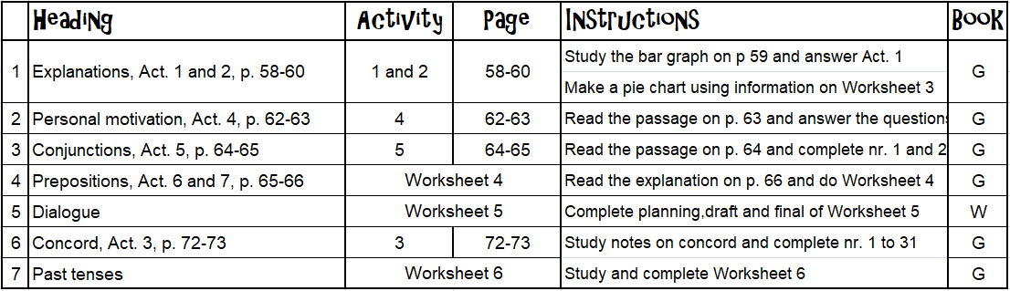

Worksheet 3: Information for a pie chart

Study the following information:

Community Survey 2016 of Agricultural households in South Africa
The information presented in the above report is generated from the Community Survey 2016. The report is the second in a series of agricultural statistics released at household level. The first report, Census 2011: Agricultural households, was published in 2013 and was generated from Population Census 2011.
This report forms part of a series of publications generated from the Community Survey 2016. Municipal data are also available on the Stats SA website using SuperWEB2 and Nesstar.
Agricultural statistics are key to the measurement of the performance of the agricultural sector. The information is mostly used for food security, decision-making, planning, and measurement of employment and research work in the sector. Other areas of interest to which agricultural statistics contribute extensively are agro-processing and eco-tourism. As in the previous survey, the biggest contributors to South African agriculture were Kwa-Zulu Natal and the Eastern Cape where 23% of the families in each province were involved in some form of agriculture. Limpopo and Gauteng both increased their percentages from the previous survey to 16% for Limpopo and 10% for Gauteng. Free State, North West and Mpumalanga all showed a decrease in the amount of families involved in agriculture – Free State and North West to 7% each, and Mpumalanga to 9%. The lowest contributors to agriculture have remained the same – Western Cape with 3% and Northern Cape with 2%.

Adapted from https://www.statssa.gov.za/publications/03-01-05/03-01-052016.pdf

Complete a pie chart to indicate the percentages of families involved in agriculture according to the above survey.
Worksheet 4: Post Office Procedure

Study the following information (taken from p. 66):

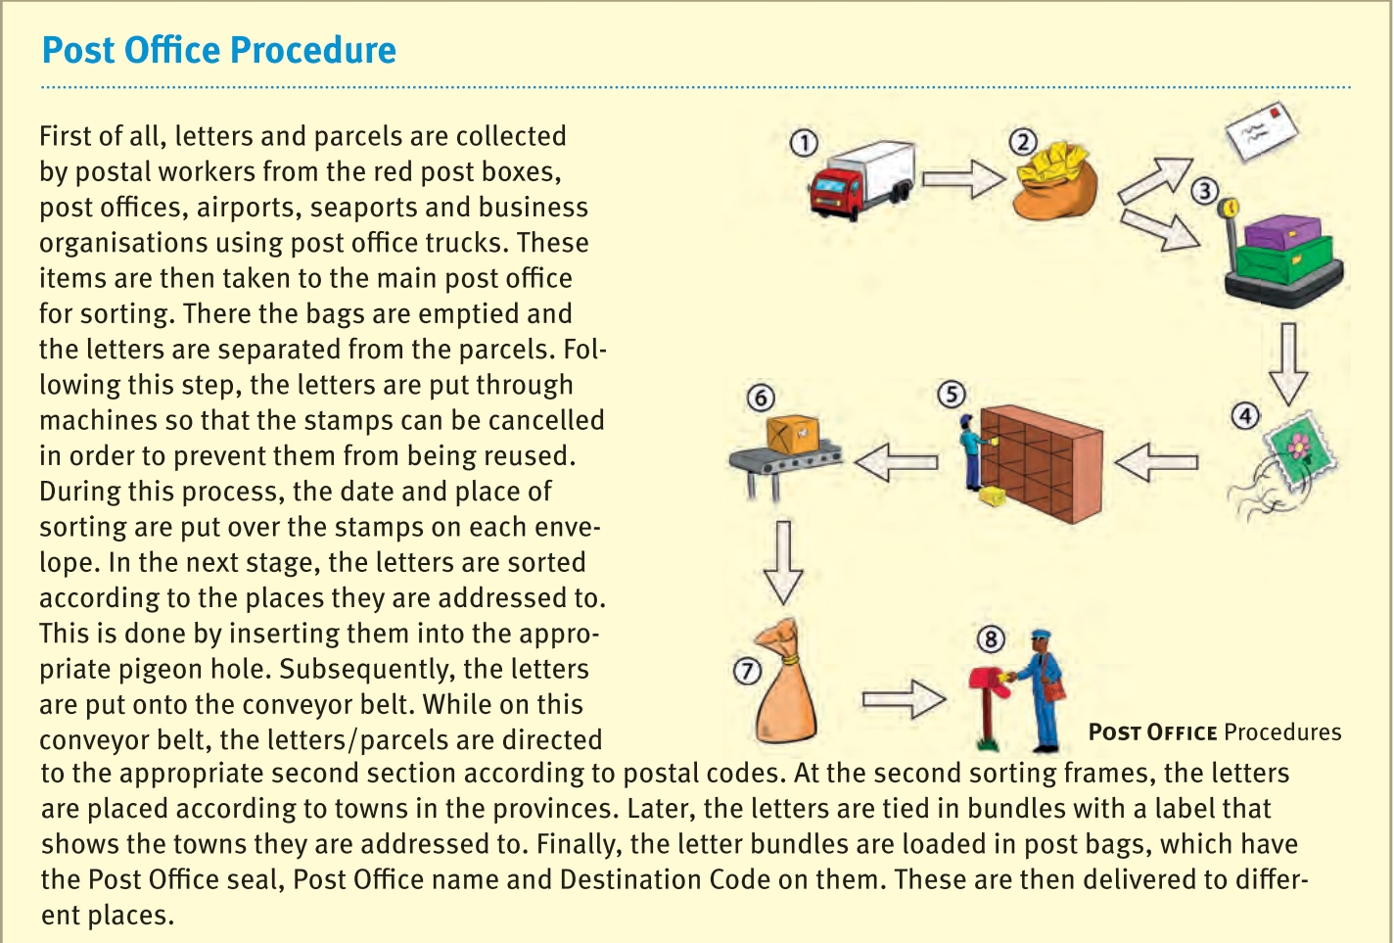
Using this information, complete the following table. Copy it into your Grammar books and fill in the needed information:
Step | Place | Action | Connectors | Preposition
1. | Post boxes, post offices, airports, seaports and business organisations. | Letters and parcels are collected and placed in trucks | First of all; and, | by; from
2.
3.
4.
5.
6.
7.
8.

Place:
Identify the place where this specific step takes place.

Action:
Identify the action taken by those involved.

Connectors:
Identify all the logical connectors (either to indicate sequence or cause/reason) in that step.
HINT: Look at page 63 again.

Prepositions:
Identify all the prepositions in that step.
Remember, a preposition is used to show the position of an object (BOX-words)
or
to show the relationship of one object to another (This gift is FROM me TO you).

Worksheet 5: Dialogue
Study the following topics:
- It is the zombie apocalypse. You are in a group of survivors who are travelling to a safe area, but there is an argument between you and another survivor about which resources to look for. Write the dialogue that takes place between you.
- On their way to school, two friends find a wallet with a large amount of money. One wants to keep the money and not return the wallet to the owner, but the other is against the idea. Write the dialogue that takes place between the friends
- Your parent does not approve of one of your friends. You have decided to convince him/her that this friend is not a bad influence on you. Write out the dialogue that takes place between you and your parent.

Choose ONE of the above topics and complete the planning, draft and final of this dialogue in your writing books. Word count: 120-150 words.
Remember to include a brief scenario before the dialogue (NOT part of word count) as well as non-verbal cues (part of word count).

Worksheet 6: Past tenses
